HAF Nottinghamshire, a guide for schools, parents and carers on how to book places on holiday clubs:

- Visit the HAF Notts website: Holiday activities and food | Nottinghamshire County Council
- Click on the ‘Find an activity button:

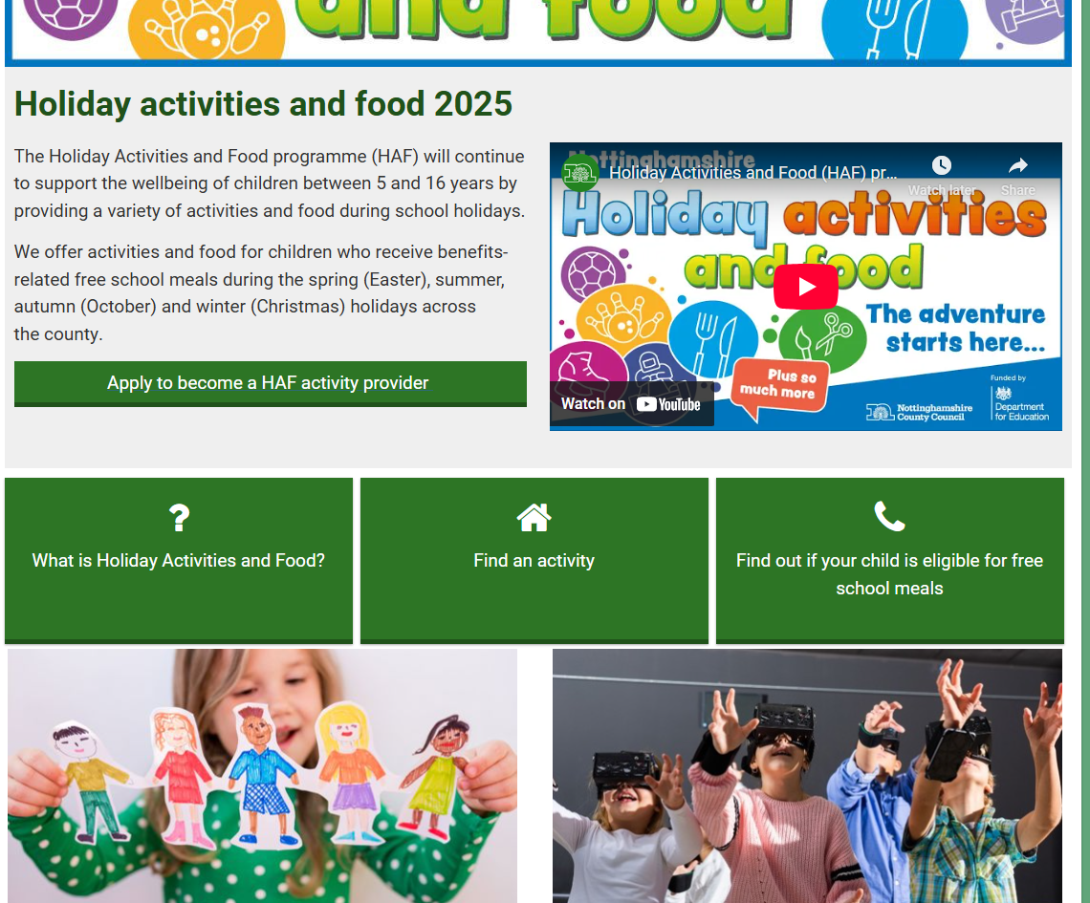

- This will then go to our new bookings page which looks like this:
=

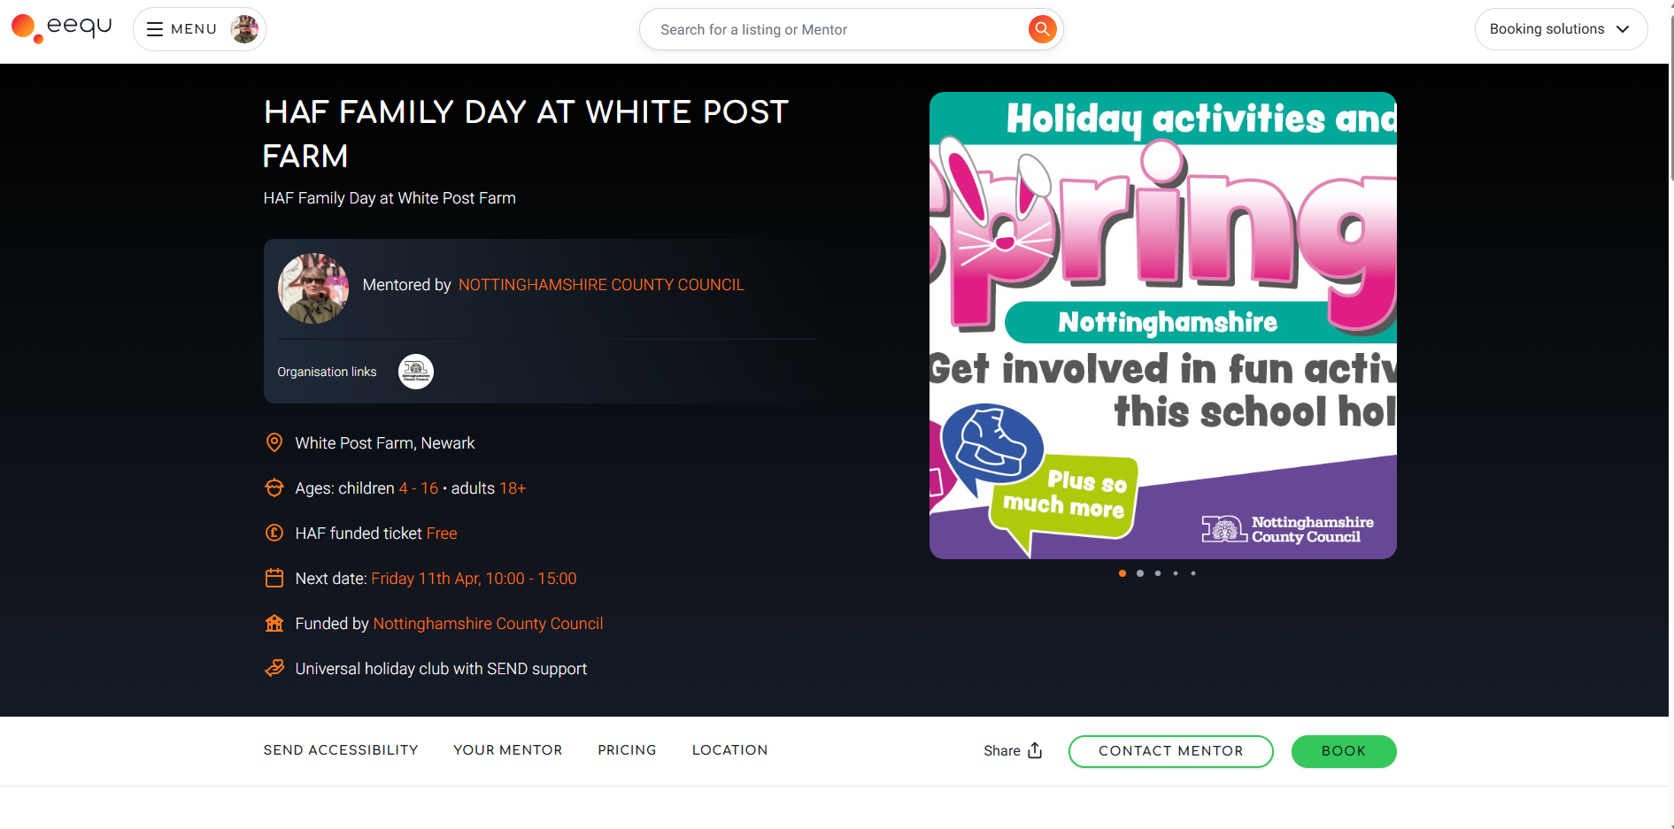
There will be a list of holiday clubs to choose from wither by scrolling, postcode search, map search, activity specific, SEND specific etc. Parents/carers find a holiday club or clubs and click the green BOOK button.
Enter all of the details for the child and a confirmation is sent directly to them with reminders to follow.

